FAS/ LD/ RES/ LPD_OP_PLAN/ CON900

BID QUESTIONS AND ANSWERS
CORRECTIONS TO BID DOCUMENT

BID ADVERTISEMENT (ERRATUM)

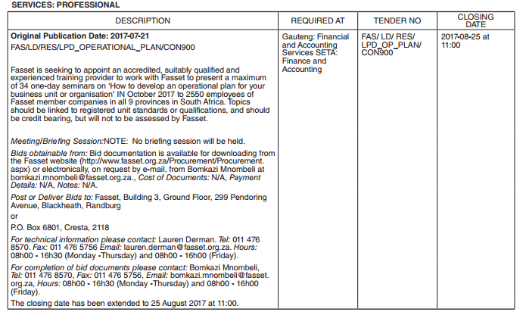

QUESTIONS AND ANSWERS

FAS/ LD/ RES/ LPD_OP_PLAN/ CON900

# | QUESTION | ANSWER
1 | Can we still bid if we are accredited by Service SETA. | Yes, you may bid provided you are accredited for a relevant qualification; the SETA you are registered with does not need to be Fasset.
2 | If posting our submission to you, should it be to your physical or postal address please? If it is to your PO address, is your mail collected daily, please?  I am away from the office, and may be able to post it to you from KZN, just worried about bid submission reaching you before the due date. | Fasset, P O Box 6801, Cresta, 2118. We collect the mail once a day around 11h00.
3 | I hereby request the bid documentation for FAS/ LD/ RES/ LPD_OP_PLAN/ CON900 on ‘How to develop an operational plan for your business unit or organisation’. | The information may be downloaded from the procurement/tender section of the website.
4 | We are in the process of putting tender FAS/LD/RES/LPD-OPERATIONAL_PLAN_DEVELOPMENT/CON900 together for submission, however, instead of a Special Conditions of Bid and Contract section, the tender has a POPI section.  Please may you forward us the missing section B1 forms. | Please refer to Section 20 of the document for the Special Conditions of Bid and Contract section.
5 | I would like clarification on the following regarding the following RFP FAS/LD/RES/LPD_OPERATIONAL_PLAN/CON900  • Do you want learners to complete POEs and for them to be assessed, moderated and certified? As it is not mentioned in the tender document.  • Will you accept a unit standard on NQF level 4 – Developing a business plan for a new venture? | - Learners do not need to complete POEs and for them to be assessed, moderated and certified.  - Aby suitable unit standard van be utilised in line with the tender brief instructions.
6 | This is to enquire about the above mentioned and attached tender with a closing date of 04 August 2017, yet yet the ad says 25 august 2017.
7 | Please may I confirm which region or province in South Africa the above mentioned tender is for. | The event is to be run nationally, as per the venues indicated in the bid document.
8 | May I please enquire: the above tender stipulates:  We are a fully accredited training provider with the Services Seta, for a number of courses. However, this one above is not one of them. We have covered this content in other learning programmes we offer.  Is the above requirement a non-negotiable with FASSET, please advise. | Any suitable unit standard can be utilised in line with the tender brief instructions.
  Accreditation requirement | Provider to be accredited against relevant qualification/part-qualification/unit standard

