FAS/LD/RES/EVENT_MANAGEMENT/CON899

BID QUESTIONS AND ANSWERS
CORRECTIONS TO BID DOCUMENT

BID ADVERTISEMENT

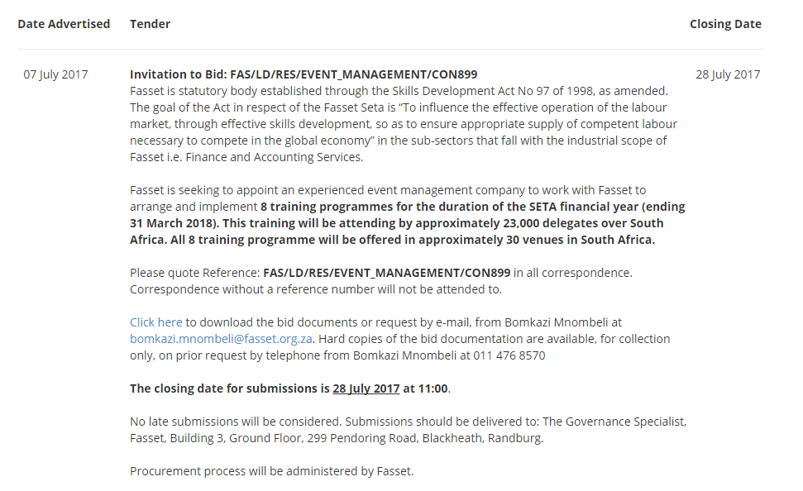

QUESTIONS AND ANSWERS

FAS/LD/RES/EVENT_MANAGEMENT/CON899

# | Question | Answer
1 | Please may I confirm the correct closing date for the above mentioned tender. | The tender closes on 28 July 2017.
2 | Thank you for the information,  please advise with regards to this ,We also need clarity on whether we just need to do the logistics or actual facilitating as well? | You will not be required to facilitate the seminars.
3 | I hope this email finds you well.  We need more information with regards to the above mentioned tender.  1. The closing date, i see the a two closing dates for this tender one is 04 August 2017 at 11:00 and on the website is stated 28 July 2017 at 11:00 kindly confirm the correct date.  2. We also need clarity on whether we just need to do the logistics or actual facilitating as well?  Your Response will be highly appreciated. | We only advertise on the Government Gazette, The National Treasury e-tender portal and the Fasset website.  I do not know the site that advertised that tender. Please refer to the Fasset website for our tenders.
4 | The documents are available in the procurement section of the Fasset website. | We are looking for the tender document for events management
5 | please advise with regards to this ,We also need clarity on whether we just need to do the logistics or actual facilitating as well? | You will not be required to facilitate the seminars.
6 | We have gone through the tender document and we have a couple of questions for clarification.  - The project deliverables are not clear, will you kindly unpack further  - When is the Start and End date of the 8 training programmes  - Are we quoting for project management only  - Do you have venues in each province or we will have to source and allocate  - What structure will the training programmes take | We have gone through the tender document and we have a couple of questions for clarification.  - The project deliverables are not clear, will you kindly unpack further LD: Your question is unclear, please unpack further.  - When is the Start and End date of the 8 training programmes LD: The dates are subject to change and we have indicated the broad dates in the bid document.  - Are we quoting for project management only LD: Please refer to the bid document (especially the pricelist) for the deliverables which are clearly indicated.  - Do you have venues in each province or we will have to source and allocate LD: You will need to source venues as per the detailed process and deliverables outlined in the bid document and pricelist.  - What structure will the training programmes take LD: Your question is unclear, please unpack further.
7 | We are interested in bidding for the attached tender, but i noticed there is no specifications for us to work from, please advise what exactly do we need to submit when tendering interms of deliverables? | All relevant information is available for download from the procurement section of the Fasset website. Three documents need to be downloaded.
8 | I hope my mail finds you well. Please could you clarify two queries for us as follows:  Question 1: Please confirm if you are wanting us as the event organizers to quote on just our management fee only or do we need to include the venue costs as well? Sorry, we just want to be 100% sure.  Question 2: On page 27 – 28 under Contract Form: Rendering Services. It gives us an example of what the service provider needs to fill in and sign but it also states that we are not allowed to retype it? Where can we find the original copies to fill in? | Thank you for your query.  You need to provide a quotation in line with the deliverables outlined in the price list to this bid.  The contract rendering form is something that must be filled in by the successful bidder only. When the successful bidder is contracted with appropriate forms will be provided. This form does not form part of the bid response.
9 | I would like to introduce my services and should I apply with the below services:  1.Project Coordination  2.Process Management using Lean Six Sigma  3.Training & Development - E-learning ( IT ,SOFT SKILLS AND BUSINESS SKILLS) INTRODUCING E-LEARNING  4.Sales Business Analysis  5.Corporate Events  All certified and accredited .  If you interested please let me know.  I am registered on CSD:******** | Thank you for your email.  I am unable to advise you as to whether the Bid Evaluation Committee (BEC) will be interested or not, as this is the objective of you submitting a bid response. It is ultimately your decision to tender or not.

CORRECTIONS TO BID DOCUMENT

# | Section | Bid Document Text | Correct to Bid Document Text
1 | Bid Advert | Fasset is seeking to appoint an experienced event management company to work with Fasset to arrange and implement 8 training programmes for the duration of the SETA financial year (ending 31 March 2018). This training will be attending by approximately 23,000 delegates over South Africa. All 8 training programme will be offered in approximately 30 venues in South Africa. | Seven events are scheduled for the duration of the contract period.
2 | 1.2.2 | Demonstrated capacity/ability to manage a project of this size. An estimated 21400 delegates are expected to be trained in 221 venues across the contract period.  - In this section the service provider should outline their organisation structure, how the project team is conceptualised and provide evidence to the SETA as to how the requirements of this tender will be addressed in terms of the ability and the availability of the proposed team.  - Ensure that explanation and evidence is included to show that the contractor can meet this criterion. A range of speakers will show national reach. Full-time staff, and/or a network of consultants, will provide the company with a greater ability to address this criterion. | Demonstrated capacity/ability to manage a project of this size. An estimated 21400 delegates are expected to be trained in 221 venues across the contract period.  - In this section the service provider should outline their organisation structure, how the project team is conceptualised and provide evidence to the SETA as to how the requirements of this tender will be addressed in terms of the ability and the availability of the proposed team.  - Ensure that explanation and evidence is included to show that the contractor can meet this criterion. A range of staff and venue hosts will show national reach. Full-time staff, and/or a network of consultants, will provide the company with a greater ability to address this criterion.
  Scoring Criteria | Points
  Organisation structure, project team structure and availability in this project, range of speakers with a national reach (i.e. situated in the centres where training is scheduled, to allow for efficiency in travel) is excellent and provided in excellent detail. | 10
  Organisation structure, project team structure and availability in this project, range of speakers with a national reach (i.e. situated in the centres where training is scheduled, to allow for efficiency in travel) is very good and provided in very good detail. | 8
  Organisation structure, project team structure and availability in this project, range of speakers with a national reach (i.e. situated in the centres where training is scheduled, to allow for efficiency in travel) is good and provided in good detail. | 6
  Organisation structure, project team structure and availability in this project, range of speakers with a national reach (i.e. situated in the centres where training is scheduled, to allow for efficiency in travel) is fair and provided in fair detail. | 4
  Organisation structure, project team structure and availability in this project, range of speakers with a national reach (i.e. situated in the centres where training is scheduled, to allow for efficiency in travel) is poor and provided in poor detail. | 2
  This section has not been completed. | 0
  Scoring Criteria | Points
  Organisation structure, project team structure and availability in this project, range of staff and venue hosts with a national reach (i.e. situated in the centres where training is scheduled, to allow for efficiency in travel) is excellent and provided in excellent detail. | 10
  Organisation structure, project team structure and availability in this project, range of staff and venue hosts with a national reach (i.e. situated in the centres where training is scheduled, to allow for efficiency in travel) is very good and provided in very good detail. | 8
  Organisation structure, project team structure and availability in this project, range of staff and venue hosts with a national reach (i.e. situated in the centres where training is scheduled, to allow for efficiency in travel) is good and provided in good detail. | 6
  Organisation structure, project team structure and availability in this project, range of staff and venue hosts with a national reach (i.e. situated in the centres where training is scheduled, to allow for efficiency in travel) is fair and provided in fair detail. | 4
  Organisation structure, project team structure and availability in this project, range of staff and venue hosts with a national reach (i.e. situated in the centres where training is scheduled, to allow for efficiency in travel) is poor and provided in poor detail. | 2
  This section has not been completed. | 0
3 | Pricelist  Quotation  10.1 | Blank | Capture delegate evaluation forms
4 | Pricelist  Quotation  10.1 | Volume driver is incorrect | Volume drivers as per instruction tab
5 | Pricelist  Summary  VAT | VAT is 1.14 | VAT should be 14%
6 | 4.1 | Detail of reference letters or assignment undertaken on a similar work in the past 5 years with information on the projects from 3 clients for each of the company proposed. | Detail of reference letters or assignment undertaken on a similar work in the past 5 years with information on the projects from 3 clients for each of the company proposed.

